**Helmet Integrated**

**Impact Detection System**

Jasmine Arrieta, Rhyan Gonzalez, Calvin Lee, Socheath Sok



   
400D**|**Electrical EngineeringSenior Design

CSULB**|**December 16, 2019

**Introduction**

Several football players experience concussions or head trauma during their practices and games. Of these players, some are not aware of concussion-symptoms or continue to play despite their head injuries. This increases the risk of developing CTE (chronic traumatic encephalopathy) which is a neurodegenerative disease common amongst professional football players. In a 2017 study published by The New York Times, 110 out of 111 players were found to have CTE [1]. To mitigate this, HI-IDS (helmet integrated impact detection system), as shown in figure 1, was created. HI-IDS is designed for football players so that they receive timely medical attention, and coaches can monitor the number and magnitude of head collisions that their players receive. Unlike other products, HI-IDS is integrated inside the helmet, small, easy to install, user-friendly, and affordable.

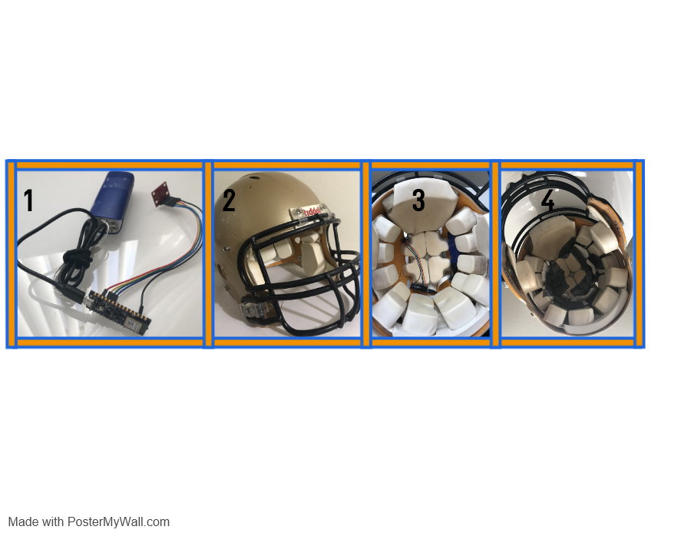

**Figure 1:** HI-IDS is shown in box 1. It can be inserted into a football helmet as shown in box 2 and 3. Box 4 shows HI-IDS covered in duct tape to keep it in place.

**Product Concept**

The concept of HI-IDS is that an accelerometer connected to an Arduino powered by a rechargeable battery is placed inside a football helmet to measure g-forces any time the helmet is struck, and send that data to an app via Bluetooth as shown in figure 2. The app shall display this data on a graph and notify the user if the accelerometer reads a g-force above 100gs which is the threshold at which a concussion is likely to occur [2].

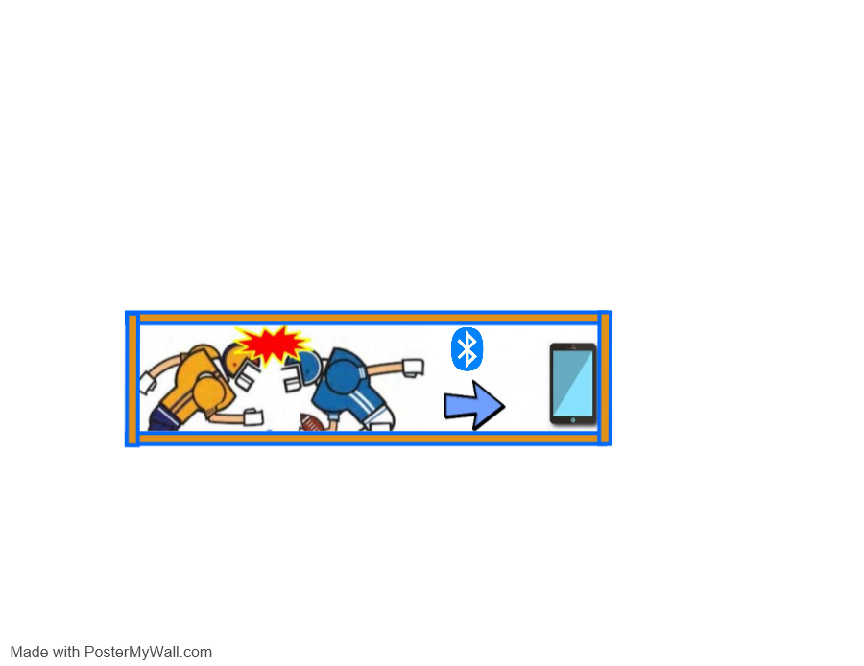

**Figure 2:** When a player’s helmet gets struck by another helmet or the player falls on his head, the hardware within the helmet will transmit this impact-data to the phone app.

**Product Objective, Features, and Use Cases**

The technical objectives for HI-IDS are to seamlessly integrate the sensor into the helmet, measure impacts between +/- 200 g-forces, provide a Bluetooth communication range of at least 50 meters and operate for at least one hour using a rechargeable battery. The desired functionalities are to measure head-collisions, transmit the data collected from the helmet wirelessly to an app, send an alert on the app when a helmet collision exceeds a certain threshold, and as shown in figure 3, display a history of impact data over a selected period. HI-IDSis suitable for football players of any level and real games and practices. The software application is controlled by coaches and physicians.

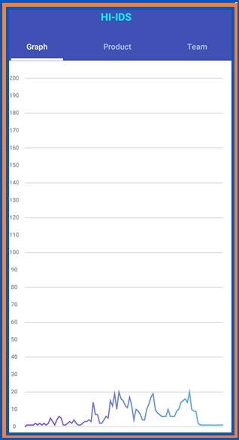

**Figure 3:** The appdisplays a history of impact data over a selected period of time.

**Full Product Development Plan**The key tasks to turn the HI-IDS prototype into a salable product are to test the hardware and software units until they meet system requirements, make the app user-friendly, and follow a calendar, as shown in figure 4, to complete HI-IDS on time.

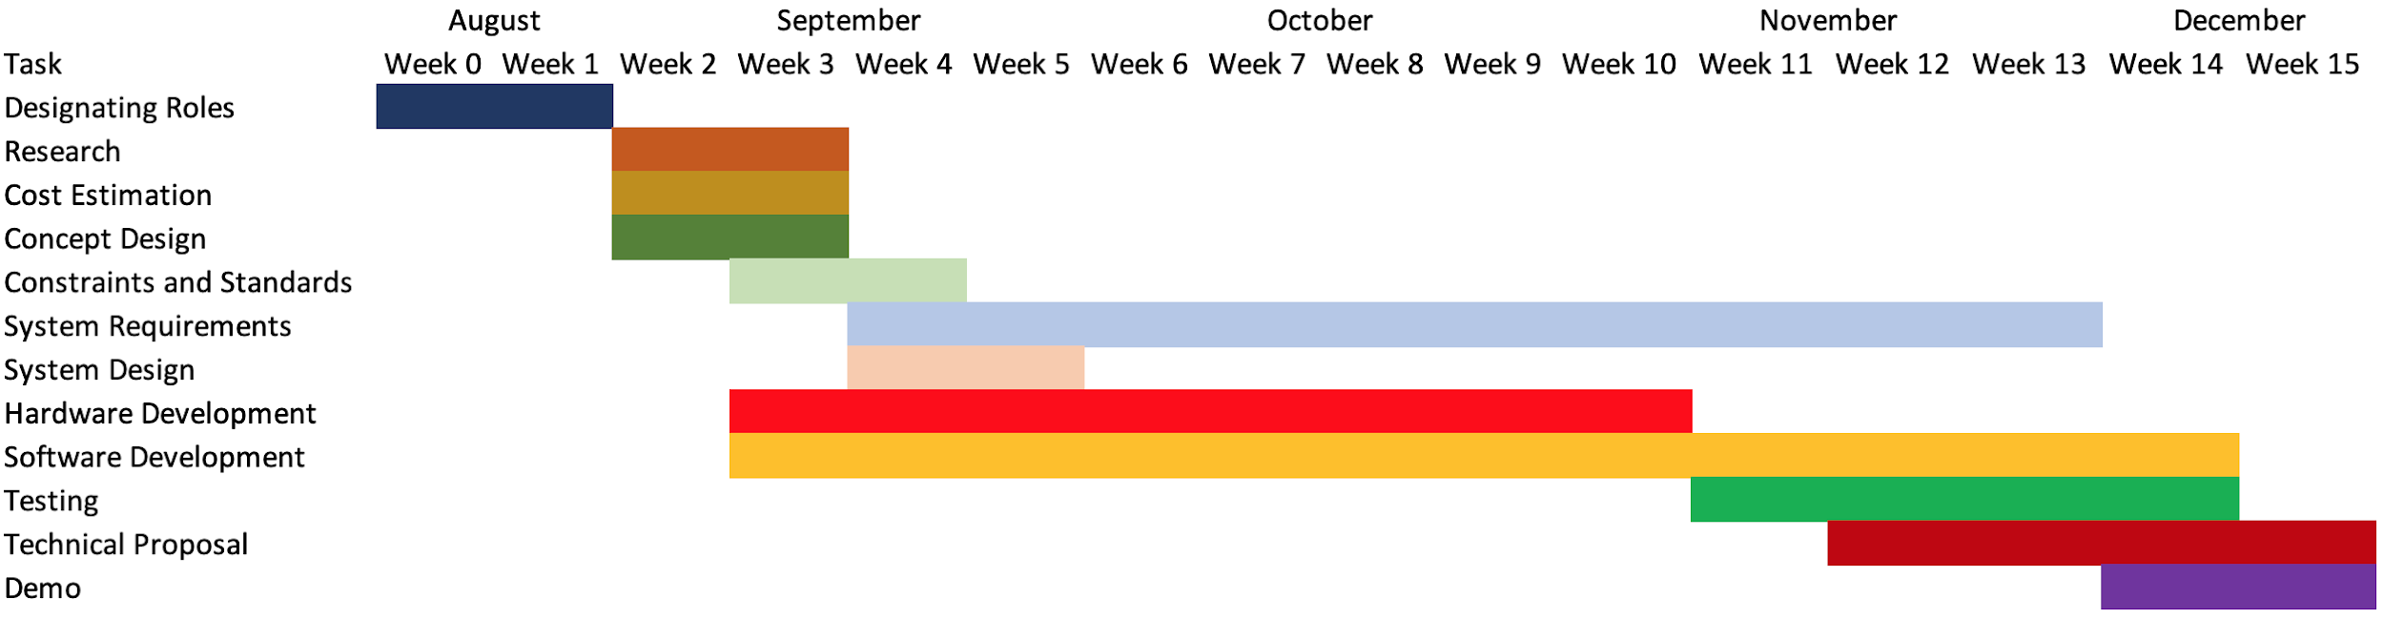

**Figure 4:** Approximate calendar schedule to complete final product design and development.

**Prototype Demonstration**

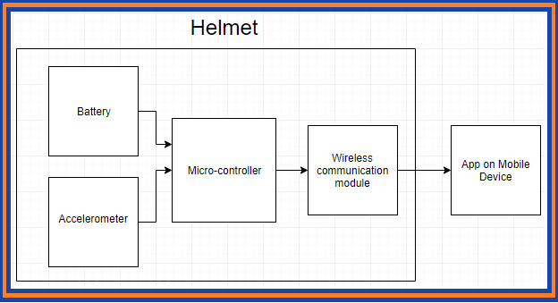

**Figure 5:** A top-level system architecture of the HI-IDS Prototype design.

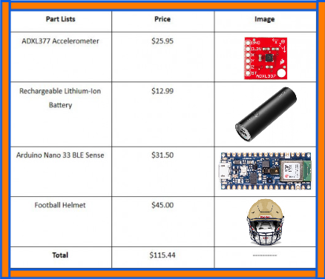

**Figure 6**: A table showing the parts purchased and price per item.

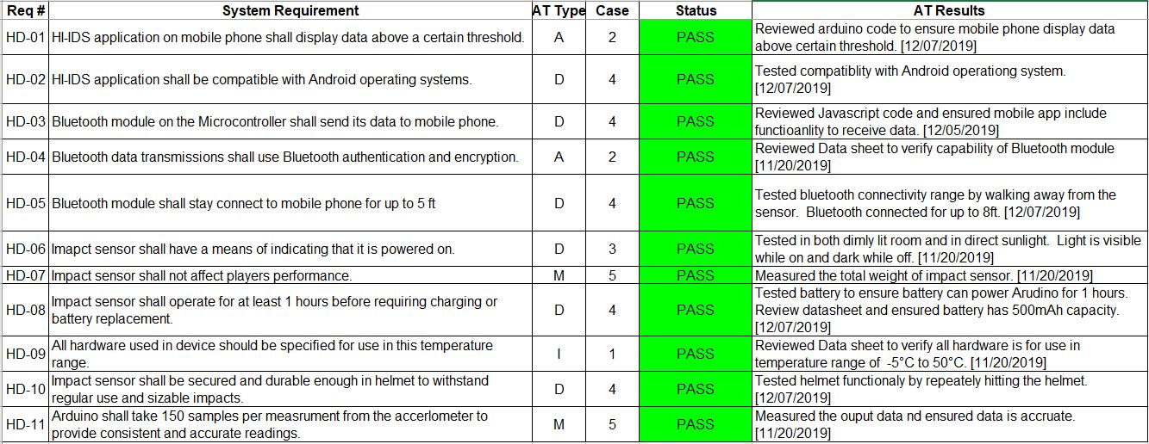

**Figure 7:** A summary of the acceptance testing & results.

**Lessons learned**

While designing the hardware, there were two main challenges. The first challenge was working with the ADXL377 accelerometer. Our team initially tried to use the raspberry pi zero to communicate with the ADXL377 accelerometer but learned that ADXL377 only outputs analog values while the raspberry pi only accepts digital inputs. So, our team bought an Arduino Nano because it is small and accepts analog inputs. Implementing the Arduino Nano’s built-in Bluetooth module was the second challenge the hardware team faced because it was difficult to find examples on how to use it since it is newer technology. Lastly, during testing, our team realized that the ADXL377 was not an accurate sensor to measure g-forces in football because this sensor can only measure g-forces when there is a change of velocity not while the player is stationary. As a result, the team learned to extensively research a component’s features and pick components that have been commonly used before buying anything.

For the HI-IDS app, we decided to use React Native due to its flexibility in terms of customizing functionalities and components. While the whole process was challenging, our research was enough to help set up multiple screens to display different types of information and establish navigation-methods. Additionally, we even learned some javascript basic which was needed to create a function that compares data value to the threshold. Learning to build an app from scratch was difficult, especially with our software experience so next time we would use a resource like MIT App Inventor.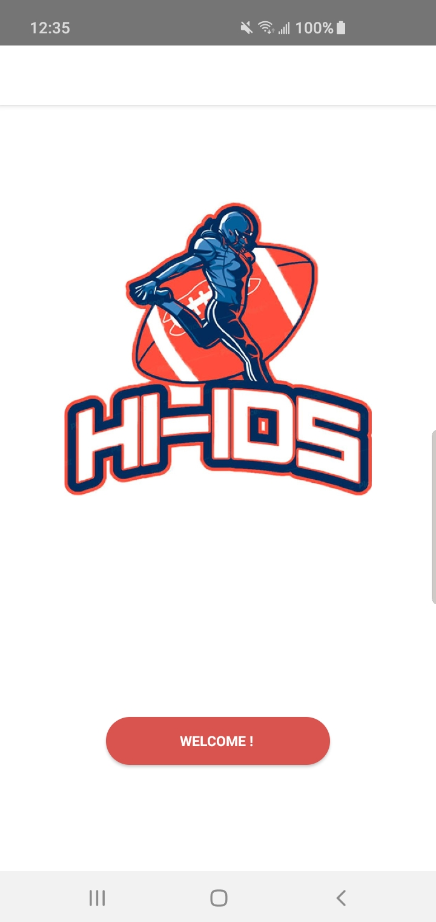

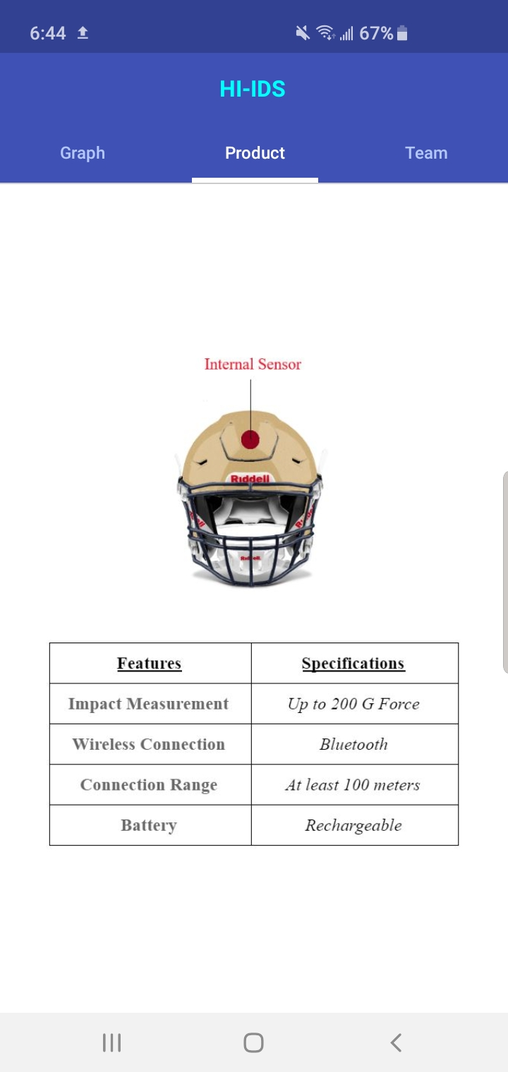

**Figure 8:** HI-IDS application has multiple displays and functions.

**Changes To Concept Due To Prototype Errors**

There were four major changes to concept due to prototype issues. Initially, our team built HI-IDS using a Raspberry Pi. After some initial testing, we found the Raspberry Pi difficult to work with. Our team then changed our concept to use an Arduino Nano instead. In our testing, Arduino Nano was easier to set up and was compatible with the analog outputs of our accelerometer, unlike the Pi. The Arduino Nano also came with a built-in Bluetooth 5 module which was a potential solution for the range that we wanted. The second change of concept we made was the compatibility between the HI-IDS application and the IOS operating system. This concept was changed due to time constraints with the software team. In order to develop an IOS application, both Macbook and iPhone are needed to use the development software Xcode. As a result, the HI-IDS application was only made compatible with Android operating systems. Finally, we also had to change our requirement of how far the Bluetooth module shall stay connected to the mobile phone and how long HI-IDS shall operate before charging is required. The Bluetooth module was unable to stay connected for more than 5ft and the battery was unable to operate for more than 1 hour before charging was required.

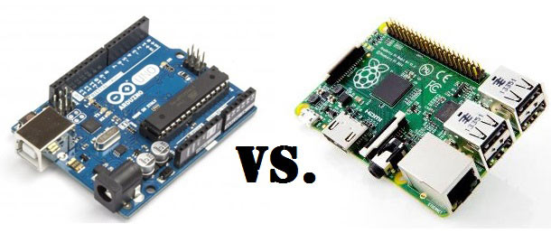

**Figure 9:** During the development process we had to make design changes due to time  
constraints, compatibility issues, and inaccurate initial estimations.

**Prototype Technical Objectives and Constraints**

| **Technical Objectives** | Seamlessly integrate the sensor into the helmet |
| --- | --- |
|  | Measure impacts between +/- 200 G force |
|  | Communication range of at least 100 meters |
|  | Powered by rechargeable batteries |
| **Functionalities** | Measure collisions to the helmet |
|  | Transmit the data collected from the helmet wirelessly to an app |
|  | Send an alert on the app when a helmet collision exceeds a certain threshold |
|  | Display a history of impact data over a selected period of time |
| **Use Cases** | Football players of any level |
|  | Real games and practices |

**Table 1:** Technical objectives, functionality, and use cases

| ***IEC 60086-4 Ed. 4.0 b:2014*** | Safety of lithium batteries |
| --- | --- |
| ***IEEE 802.11b-1999*** | Wireless communication |
| ***IEEE 836-2001*** | Recommended practice for testing accelerometer |
| ***ISO/IEC 9126-1:2001*** | Systems and software Quality Requirements and Evaluation |

**Table 2:** Safety and Standards Usage

| **Social and Ethical** | *Accessibility* | The app would be available on IOS & Android |
| --- | --- | --- |
|  | *Functionality* | Impact measurement and transfer of data |
|  | *Usability* | Simple user-interface |
| **Manufacturability** | *Constructability* | Stable connection between components |
|  | *Size, Weight, & Power* | Hardware must fit into the helmet |
|  | *Standards* | Accelerometer, Bluetooth and battery |
| **Environmental** | *Toxic Waste* | Lithium-Ion battery |
| **Economic** | *Cost* | Must not exceed $85 |
|  | *Extensibility* | Connection to multiple devices |
|  | *Interoperability* | Shareable data |
|  | *Schedule* | Steps completed by the due dates |
| **Health and Safety** | *Safety Standards* | The system must not overheat |
| **Political** | *Policy and Regulations* | The design is based on a tutorial on Sparkfun |

**Table 3:** Key Realistic Constraints

**Key Personnel**

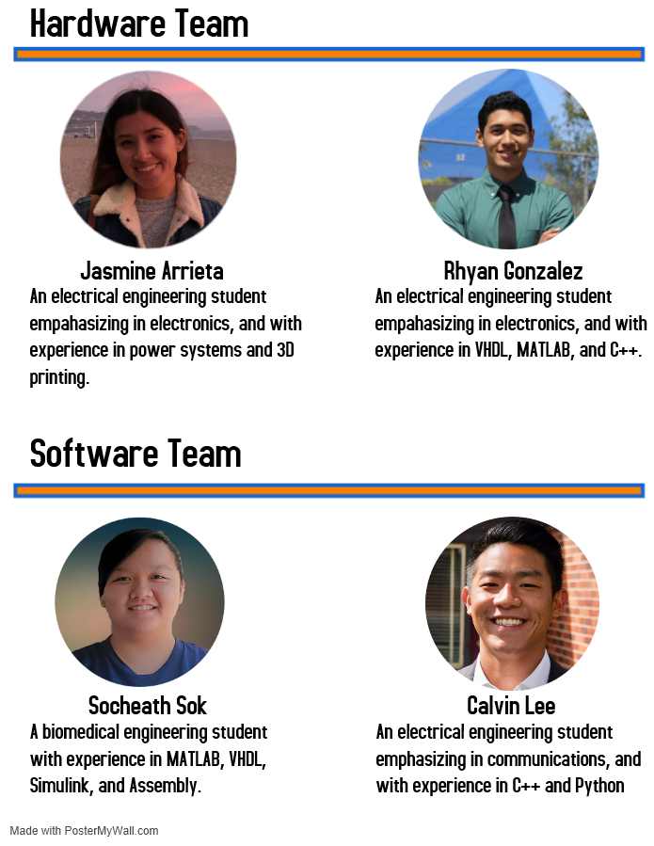

**References**

**[1]** Ward, Joe, et al. “111 N.F.L. Brains. All But One Had C.T.E.” *The New York Times*, The New York Times, 25 July 2017,   
https://www.nytimes.com/interactive/2017/07/25/sports/football/nfl-cte.html.

**[2]** Broglio, Steven P, et al. “Biomechanical Properties of Concussions in High School Football.” *Medicine and Science in Sports and Exercise*, U.S. National Library of Medicine, Nov. 2010, https://www.ncbi.nlm.nih.gov/pmc/articles/PMC2943536/.

**[3]** Raspberry Pi Zero Helmet Impact Force Monitor,

https://learn.sparkfun.com/tutorials/raspberry-pi-zero-helmet-impact-force-monitor.